Leeds for learning booking guide

https://www.leedsforlearning.co.uk/

You need to be a Leeds setting and be logged into your Leeds for Learning account. If you don’t have one, you can sign up here Leeds for Learning
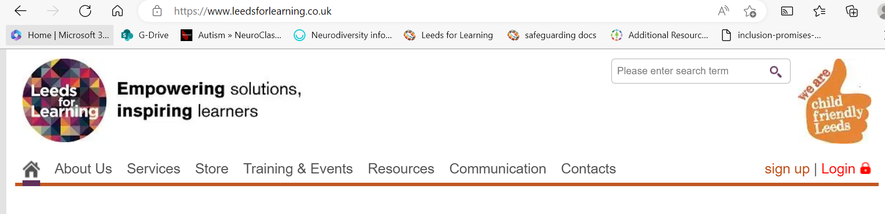
You will find Log in/sign up on the top right

Once logged in click on the training tab
Type stars in the find a course box
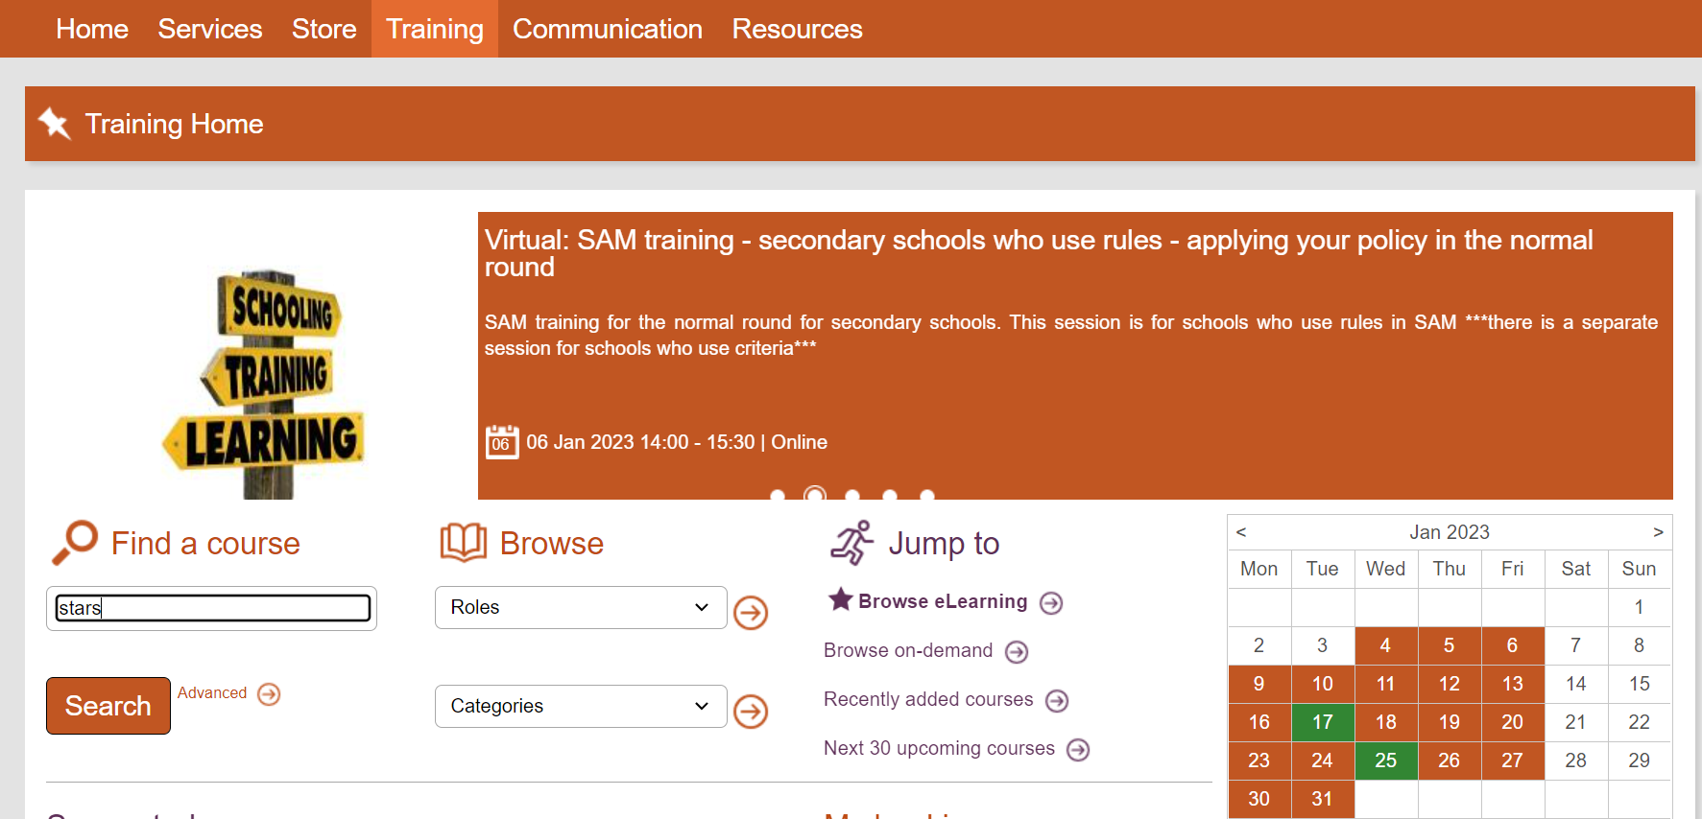

On this page you have three tabs;
Scheduled is training available to book for individuals which maybe virtual or face to face

On-demand is training bookable for whole settings which maybe virtual or face to face

eLearning is pre-recorded virtual training you can book and then complete in your own time

Click on the tab for the type of training you require. Scroll through the list to find the specific training package your looking for – click on the link and follow the instructions. Remember you will have to ‘check out’ the training from your ‘basket’ to confirm. Please be aware all the correspondence will go to the email address you used to log in.

